On Thanksgiving Day
by
Thanksgiving

The first Thanksgiving celebration was held in 1621. The long terrible winter of the previous year had been difficult for the Pilgrims. Many of the Pilgrims had died because of illness and lack of shelter. The
Thanksgiving celebration was held after the Pilgrims had their first harvest—after they had gathered their first crops.

The writings of the Pilgrims tell us that about 140 people attended the three-day celebration. Ninety of the people were Indian men and about 50 people were Pilgrims. Only four of the Pilgrims at the party were women. The feast was held outside because the Pilgrims did not have a building large enough to hold so many people.

The Pilgrims were thankful for the harvest and for the help of the native people in teaching them to grow crops in America. Without their help, the Pilgrims would have had little to eat. The menu for the first Thanksgiving included venison, or deer meat, and fowl, which included ducks, geese, and turkeys. Sea bass, cod fish, cornmeal, fruits and vegetables were also served.

Games were played, and singing and dancing were also part of the celebration. Praises were given to God for the harvest and for the Pilgrims that survived the harsh winter.

Thanksgiving in America is now celebrated on the fourth Thursday in November. Families prepare a meal similar to the meal prepared by the Pilgrims and Indians many years ago. It is a time for counting the many blessings we have received during the year and for spending time with family and friends.

My Thanksgiving Tradition

.

Cornucopia
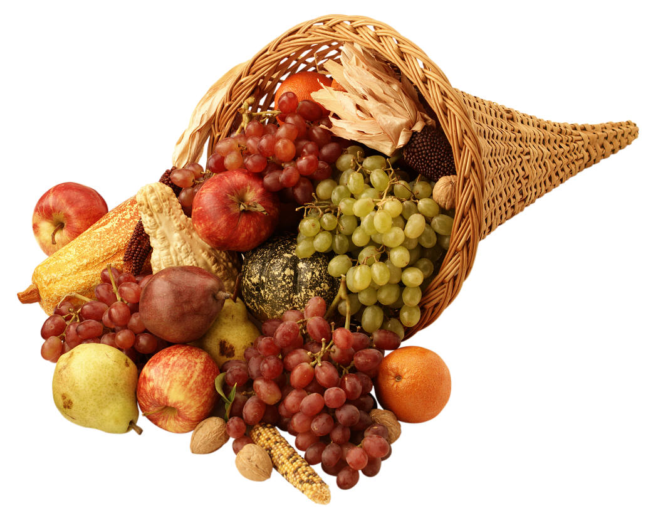

Brimming with the fruits of the harvest, the cornucopia has become an important symbol of American Thanksgiving. Its origins go further back in time to the ancient Greeks. According to their myths, young Zeus gave his foster mother, Amalthaea, a goat's horn that could be filled with whatever she wished.
Through the years, the cornucopia or horn of plenty has been used in art and decoration to show that there is more than enough of the good things in life.
Whether you call it a cornucopia or a horn of plenty, the traditional basket filled with harvest time goodies such as grapes and apples is everywhere on Thanksgiving Day.
Turkey
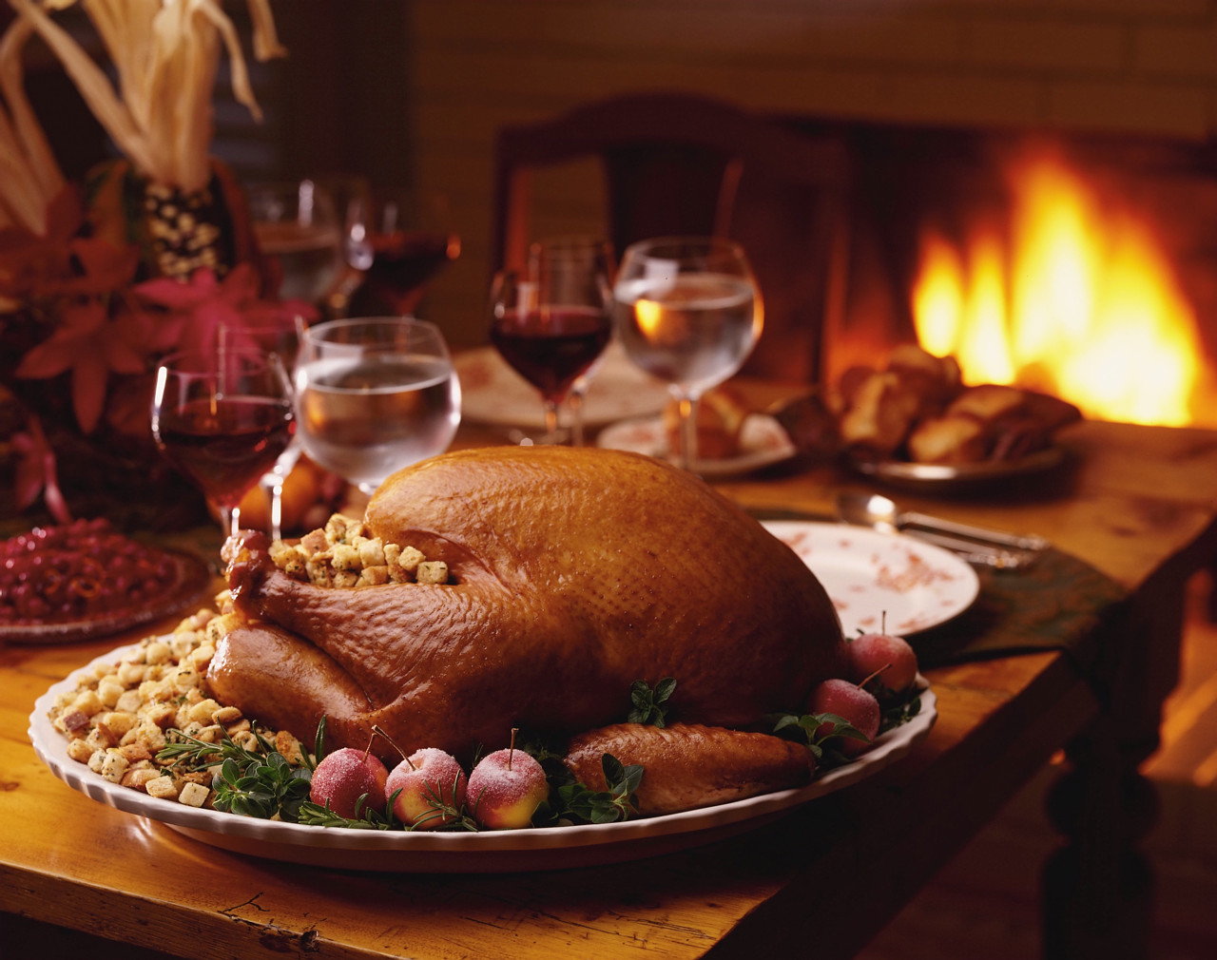

The turkey is one of the most famous birds in North America. In fact, Benjamin Franklin wanted to make the wild turkey, not the Bald Eagle, the national bird of the United States!
The turkey's popularity comes from the American people's love of eating the bird for special occasions like Thanksgiving and Christmas.
The wild turkey we usually see in photos or pictures is not the same as the domestic turkey that we serve at Thanksgiving.
Domestic or tame turkeys weigh twice what a wild turkey does and are raised on farms for profit. Most domestic turkeys are so heavy they are unable to fly.

I Am Thankful

My Thanksgiving Dinner

.

