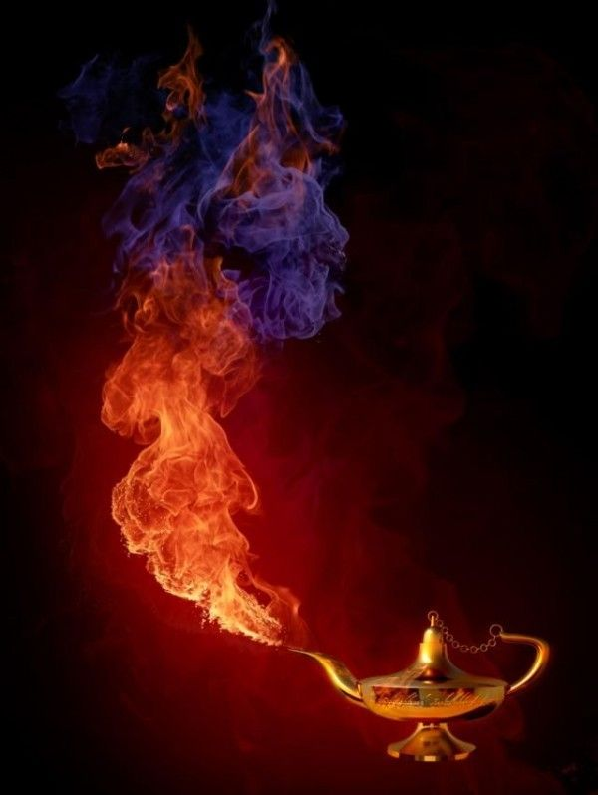
Title:
by

Although the genie lamp had brought her nothing but trouble, _____________knew she/he had to make one more wish.

