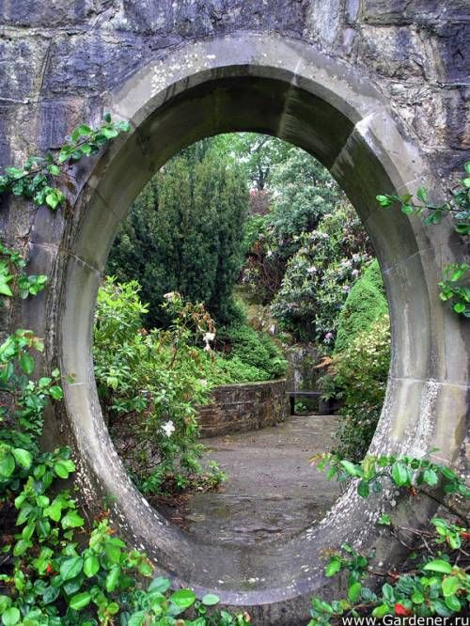
Title:
by

When _____________ found the opening in the garden wall that was not there yesterday, she/he knew exactly what she/he had to do.

