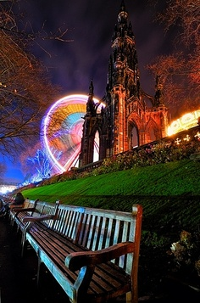
Title:
by

______________knew the amusement park had been closed for several months, the sound of carnival music and the sudden appearance of neon lights unnerved her/him.

