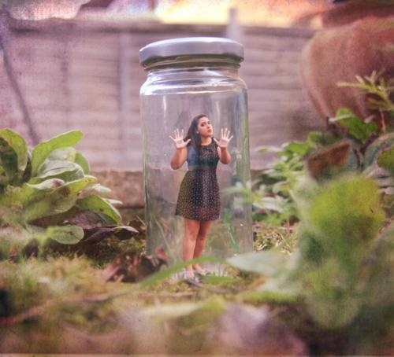
Title:
by

________________ ignored the "Enter At Your Own Risk" sign on Mr. Sedgewick's property line, she had no idea what the consequences would be.

