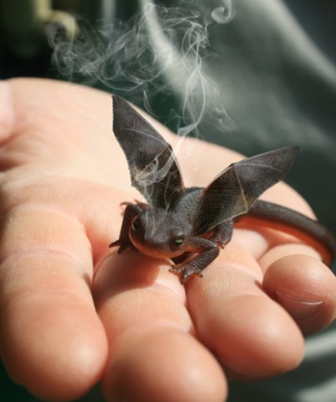
Title:
by

__________________ saw the smoke rising from the tiny reptile's head; he placed the creature in a box and headed for the lab.

