Can a species be puled back from the edge of extinction? If you consider the case of the trumpeter swan, the answer would seem to be yes. The trumpeter swan is native to North America. It is a very large bird. For hundreds of years it was hunted, both for food and for its skin. By 1932 only sixty-nine trumpeter swans were known to exist (Madson 583).
In 1935 the United States government set up the Red Rocks Lakes Migratory Waterfowl Refuge in an attempt to save the trumpeter swan from dying out completly (Mackenzie 42). Today nearly ten thousand of these birds exist in the United States and Canada (National Geographic 583). This “most majestic of american waterfowl” seems to be safe from extinction.
In a world increasingly full of people and their creations, is there any room left for wild animals? It's true that many species have adapted to humans by feding out of our garbage cans, perching on power lines, and nesting on billboards. But what about creatures that are shy and easily disturbed by people? What about species that need large undisturbed forests or plains in which to roam about and feed? One answer to saving these animals is to create wildlife refuges.
Over the past centry many such sanctuaries have been created in the United States. In 1903 Presdent Theodore Roosevelt created the first federal wildlife refuge on Pelican Island in Florida. Today there are more than four hundred such refuges across our nation.
Many American refuges have been set aside specifically to help preserve an endangered species. The whoping crane can find a protected home at a Texas refuge called Aransas. The American buffalo can roam safely over the National Bison Range in Montana. In Indonesia rangers at the Ujung Kulon National Park protect the endangered Javan rhino from hunters. Wildlife refuges in the United States seek to promote the survival of wildlife but not necessarily to leave the natural environment completely untouched by humans.
In many refuges hikers and other visitors are welcome to enter and obsrve the animals. In some refuges people are allowed to hunt, fish, and boat. Wildlife managers may dam up ponds, create nesting sites, or plant food crops to help a species survive.
Wildlife refuges are an important part of the solution to how humns and animals can live in harmony. Many species have been helped. Many visitrs have been educated.

Works cited:
Madson, John. “American Waterfowl: Troubles and Triumphs.” National Geographic Nov. 1984: 583.
Mackenzie, John P. S. Birds in Peril. Boston: Houghton Mifflin, 1977.

Directions:
Read this draft of a research paper. Follow the instructions to format the paper. Reread the paper. Write a concluding paragraph. Pay special attention to how the writer has organized the information into an introduction, a body, or the main part of the paper, and a conclusion. Then answer the questions. Finally, proof read the paper and make corrections.
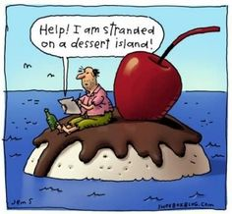
Formatting:
- Font size to 12
- Font style Times New Roman
- Add a title.
- Center Title
- Set margins to 1 inch.
- Tab to Indent Paragraphs
- Double Space
- Add a header with your name.
- Right Align Your Name
- Add Page # at the bottom of the page.
- Spell & Grammar

Write the Conclusion
Write a concluding paragraph for the research paper. Now that you have carefully reread the research paper, write a conclusion that briefly summarizes the facts for the reader and provides a sense of closure. Start by briefly restating the thesis statement, and then remind the reader of the points covered over the course of the paper.
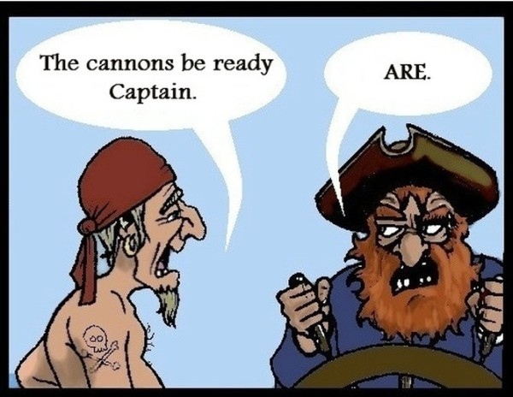

Questions:
What is the main idea expressed in the introduction?

What are the major supporting details provided in the body of this report?

Can you find any information in the body of the report that doesn’t fit the main focus of the paragraph in which it is located?
If so, what is this information, and should it be moved or deleted?

Editing the Research Paper
Proofread the following section of a completed research paper.
Read the paper several times, each time looking for different kinds of errors.
Use the list of reference works at the end of the paper to check the documentation.
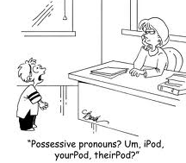
Add your corrections directly on the paper.
Proofread for these errors:
• omitted words • punctuation errors
• misspelled words • capitalization errors
• grammar and usage • documentation errors

