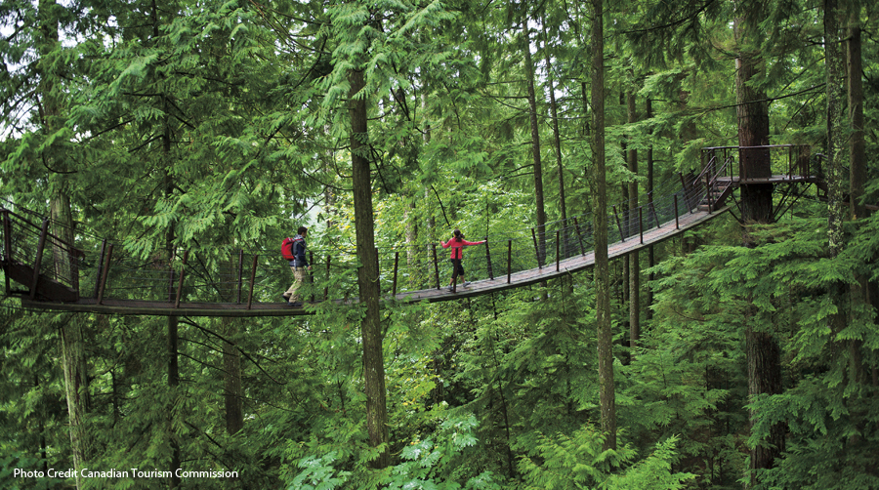

A picture is worth a 1,000 words. As I look at this photography it reminds me of a great adventure I had with some friends. Sit back a let me tell you the story.

