One of the most hopefulest developments in wildlife conservation occurs when an animal is successfully brought back, or reintroduced, to a region from which it once disappeared. For reintroduction to work, something in the enviroment must of improved. New laws may protect animals that were once overhunted. Polluted waters may have been cleaned up. Humans may have built new nesting sights to take the place of original nests, which were somehow lost. Once an anmimal has vanished from an area, people usually have to become involvedto bring it back.
One animal that has been successfully reintroduced is the wild turkey, a native American bird. Seven to ten million of these birds once ranged across the United States (Smithsonian, 54). These birds was so numerous no one could really imagine what it would be like without them. “They (turkeys) seemed to be everywhere within their Eastern range, from southern Ontaria to Florida and Mississippi, and west from the prairies of Illinois and Missouri to the eastern most part of Kansas, Oklahoma and Texas, eith specially dense populations in the Ohio River Valley” (Madson 56). However, by the middle of this century, this distinctive American game bird had became extinct in eighteen states (DiSilvestro 46). Concerned individuals realizzed that there were only about thirty thousand of the birds left in a few remote regons (Madson 54). In the mid-1950s a new net was invented that could be used to trap these shy, clever birds. Wildlife managers found that they could go to areas where wild turkeys still lived capture some birds and transport them to regions where people were eager to reestablish the wild turkey. The plan worked. Today there are over three million turkeys spread all over the place (Madison 59).
The state of missouri now has too many wild turkeys! Worked out a clever deal. Every year Missouri trades some of it's extra turkeys to Kentucky in exchange for river otters. David Hamilton, a wildlife specialist with the Missouri Department of conservation says, “We want otter and Kentucky wants turkey. We've got plenty of turkey, and since Kentucky doesn’t have surplus otter, they have to get them in Louisiana” (Schwartz 138). This type of trading among states to preserve endangered wildlife has become common practice.
Although these playful acrobats are not on the federal list of endangered species, they have have disappeared from many states (DiSilvestro 182). In 1976 residents of Missouri voted yes on a “consrvation sales tax” (Schwartz 146), and one of the popularest programs paid for by this tax has been otter reintroduction. Hundreds of people usually show up to watch as the lively little animals are released into a river. Some disappear quickly, but others prance and play for their delighted audience.
Many species, like the wild turkey, has become endangered because they were hunted for food. Others were trapped for their fur, as the otter. Wolfs, however, was drived away from their original homes by settlers who hated and feared them. Is there any hope for their reintroduction?
Recently, the U.S. Fish and Wildlife Service began too reintroduce the red wolfe to lands in North Carolina (Grove, 818). The results are very good. For example, at least 22 wolves were born during the five years of the program. And the people who live near the area is enthusiastic about the project.

Works cited:
DiSilvestro, Roger L. The Endangered Kingdom. New York: Wiley, 1989.
Grove, Noel. “Quietly Conserving Nature.” National Geographic Dec. 1988: 818–845.
Madson, John. “A Very Wise Bird Is the Turkey.” Smithsonian May 1990: 54–59.
Schwartz, David. “Otters: The Stand-up, Slide-down Comics.” Smithsonian June 1989: 138–146.
Red Wolf Reintroduction: Alligator River National Wildlife Refuge. Fish and Wildlife Service. 23 June 2000 <http://bluegoose.arw.r9.fws.gov/NWRSFiles/WildlifeMgmt/SpeciesAccounts/Mammals/RedWolf/RedWolfSummaryData.html>.

Directions:
Read this draft of a research paper. Follow the instructions to format the paper. Reread the paper. Write a concluding paragraph. Pay special attention to how the writer has organized the information into an introduction, a body, or the main part of the paper, and a conclusion. Then answer the questions. Finally, proof read the paper and make corrections.

Formatting:
• Font size to 12
• Font style Times New Roman
• Add a title.
• Center Title
• Set margins to 1 inch.
• Tab to Indent Paragraphs
• Double Space
• Add a header with your name.
• Right Align Your Name
• Add Page # at the bottom of the page.
• Spell & Grammar

Write the Conclusion
Write a concluding paragraph for the research paper. Now that you have carefully reread the research paper, write a conclusion that briefly summarizes the facts for the reader and provides a sense of closure. Start by briefly restating the thesis statement, and then remind the reader of the points covered over the course of the paper.
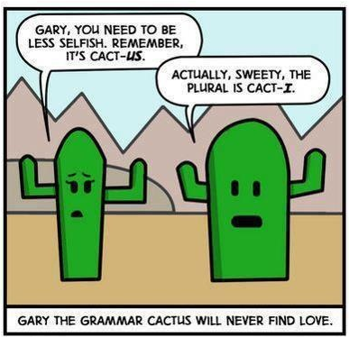

Questions:
What is the main idea expressed in the introduction?

What are the major supporting details provided in the body of this report?

Can you find any information in the body of the report that doesn’t fit the main focus of the paragraph in which it is located? If so, what is this information, and should it be moved or deleted?

Editing the Research Paper
Proofread the following section of a completed research paper. Read the paper several times, each time looking for different kinds of errors. Use the list of reference works at the end of the paper to check the documentation. Add your corrections directly on the paper. Proofread for these errors:
• omitted words • punctuation errors
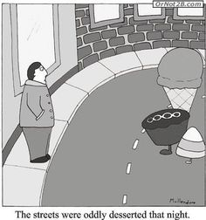
• misspelled words • capitalization errors
• grammar and usage • documentation errors

