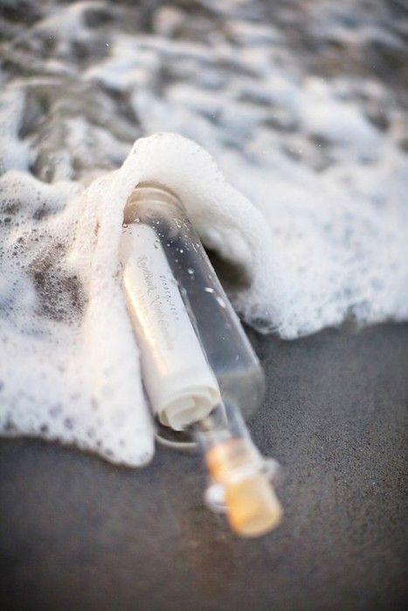
Title:

By:

When I found the bottle near the shoreline, I felt compelled to read the note which had been tucked inside it.

