

RAPP
A Constructive Response

Restate the Question
Change the question to a statement to begin your short answer response.
Answer the Question
Determine your answer and state it in a complete sentence.
Prove it with Text
Reread and search the text, find at least 2 supporting details that prove your answer, and then rewrite into your response.
Proofread and Edit
Does my answer make sense?
Have I used punctuation correctly?
Are all capital letters used correctly?
Are all words spelled correctly?
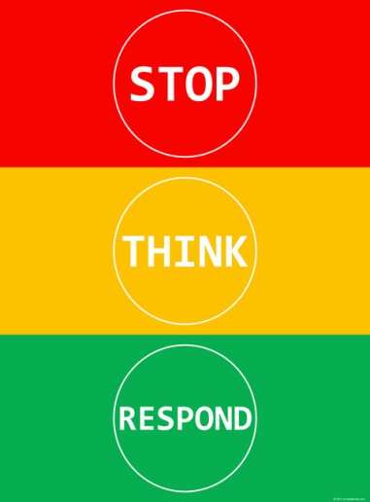
Name:

- Explain and give an example of each of the following statements as they apply to computer use.
- Stop and read all information carefully.
- Think about and organize a reasonable answer.
- Respond with a comprehensive and logical statement.

- Demonstrate proper care of equipment.

- Demonstrate respect for the rights of others while using the computer.

- Identify uses of technology at home and at school.

- Demonstrate acceptable behavior at the computer and in the lab.

- Respect the privacy of other students work.

- Identify and use: template, file management, folder, column, row, cell, cell address, data, formula (sum, average), transitions, builds, background, animation, border, bullets.

- Select and use software for the assigned task (presentation, spreadsheet, word processor, etc.).

- Perform searches for text, audio, video and graphics. (Internet)

- Evaluate acquired information for validity and usefulness.

- Demonstrate an understanding of copyright by citing sources of copyrighted materials in papers, projects, and multimedia presentations. (Understand plagiarism.)

- Navigate a Web site to gather information.

- Use Internet to capture and insert graphics into documents and acquire information.

- Use electronic reference tools.

- Listen to and follow directions and computer commands.

- Participates and completes tasks in a timely manner.

