The introduction of foreign species to Hawai has greatly affected the populations of the islands’ native species. In many cases, the introduction of forign species has wiped out the entire population of certain species, rendering them extinct. This is especially devastating because many of these species are endemic, meaning they are found only in one partcular location and nowhere else in the world. The majority of species living in Hawaii are the result of thousands of years of island biodiversity. A few birds of one species migrate from some distant island due to some rare occurrence of nature and eventually evolve into several new speces, each perfectly adapted to the environment in which it has come to live. Unfortunately, each of these endemic species is especially susceptible to the effects of invasive species, which means the impact on Hawaii’s animal life has been tremendous.
When goats were first introduced to Hawaii by Captain Cook in the late 1700s, they imediately began eating all the local plant life. Most of these plants were unsed to being preyed upon until the introduction of foreign species into their habitat, and so suffered massive population loss from grazing animals. The goat population, on the other hand, grew rapidly, as it had no natural predators to keep it in check. The introduction of European pigs to Hawai had similar effects on the native species, although, due to a scarcity of protein in natural Hawaian forests, the European pig population did not grow as rapidly as the goats until the 1900s with the introduction of earthworms and foreign plants which made up large portions of the pigs' diets (Stone and Loope 1987).
European pigs and goats are both primarily grazing animals, meaning their diet consists mostly of plant life found near the ground. Rats, mice, and mongooses, howver, are easly able to reach low hanging branches of trees containing fruit, seeds, and sometimes even bird nests. Mongooses were first introduced to Maui in the 1880s to prey upon rats in sugarcane fields and quickly extended their range to include almost evry hospitable noook in the island. They feed on most plants and animals smaller than them, including lizards, insects, crabs, rodents, small birds, and especially eggs (Stone and Loope 1987). This large prey base of exotic species has allowed the mongoose population to increase in density and range, as well as enabling it to rapidly gain stability while expanding into new areas (Vitousek et al. 1987). Mongooses spread rapidly across the island of Maui, occupying space and devastating the populations of any native species in there territory. There has been much debate over whether or not the mongooses are a limiting factor on the native bird speces of Hawaii, particularly the ground-nesting species, since they will often eat eggs and even gosling birds (Stone and Loope 1987).
Humans are not only indirectly responsible for the reduction and extinction of native Hawaiian species through the introduction of invasive species, but are also sometimes the direct cause. The Townsend's shearwater, on of the handful of surviving Hawaiian seabirds, are greatly affected by the light polution from both urban and resort locations in Hawaii. These birds, whose breeding colonies were undiscovered until the late 1960s, are blinded and disoriented while flying from inland nesting areas to the coast, causing them to crash, often in the developed areas producing the lights, where they are usually killed by cars or household pets (Scott et al. 1988). Younger shearwaters are the most susceptible to being disoriented by light pollution; therefore, the majorty of birds killed this way are to young to have reprodced, leading to a shearwater population of mostly older birds with few young to take their place and ensure the continued survival of their own species. This problem, first observd in 1961, has elevated as more and more land was developed in response to Hawaii's booming tourism in the 1970s. Recently, new methods have been put into action hoping to reduce including the use of light-blocking shelds to reduce light polution.

Works Cited
Scott, J.M., C.B. Kepler, C. van Riper III, and S.I. Fefer. 1988. Conservation of Hawaii's vanishing avifauna. BioScience 38(4):238-253.
Stone, C.P., and L.L. Loope. 1987. Reducing negative effects of introduced animals on native biotas in Hawaii: What is being done, what needs doing, and the role of national parks. Environmental Conservation 14:245-258.
Vitousek, P.M., L.L. Loope, and C.P Stone. 1987. Introduced species in Hawaii: Biological effects and opportunities for ecological research. Trends in Ecology and Evolution 2(7):224-227.

Directions:
Read this draft of a research paper. Follow the instructions to format the paper. Reread the paper. Write a concluding paragraph. Pay special attention to how the writer has organized the information into an introduction, a body, or the main part of the paper, and a conclusion. Then answer the questions. Finally, proof read the paper and make corrections.
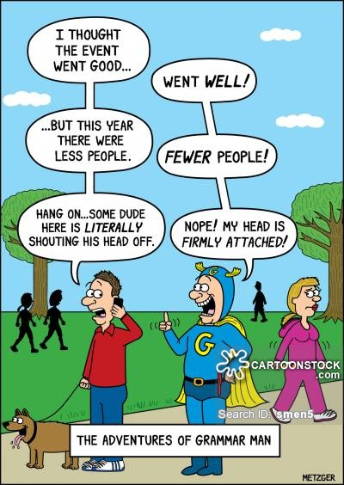
Formatting:
- Font size to 12
- Font style Times New Roman
- Add a title.
- Center Title
- Set margins to 1 inch.
- Tab to Indent Paragraphs
- Double Space
- Add a header with your name.
- Right Align Your Name
- Add Page # at the bottom of the page.
- Spell & Grammar

Write the Conclusion
Write a concluding paragraph for the research paper. Now that you have carefully reread the research paper, write a conclusion that briefly summarizes the facts for the reader and provides a sense of closure. Start by briefly restating the thesis statement, and then remind the reader of the points covered over the course of the paper.

Questions:
What is the main idea expressed in the introduction?

What are the major supporting details provided in the body of this report?

Can you find any information in the body of the report that doesn’t fit the main focus of the paragraph in which it is located?
If so, what is this information, and should it be moved or deleted?

Editing the Research Paper
Proofread the following section of a completed research paper.
Read the paper several times, each time looking for different kinds of errors.
Use the list of reference works at the end of the paper to check the documentation.
Add your corrections directly on the paper.
Proofread for these errors:
• omitted words • punctuation errors
• misspelled words • capitalization errors
• grammar and usage • documentation errors



