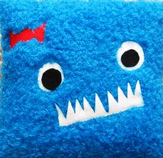

Title:

by

Ben was really worried. Yesterday he lost a tooth. Last night, he put it under his pillow. When he woke up, the tooth was gone. Where did it go? Who wanted it? It was a used tooth. It was dirty and old. There was money under the pillow, too. Where did the money come from? Who put it there? He was starting to think there was a monster that lived on his bed. It was probably his pillow. Was his pillow alive? Did his pillow wake up at night like a bat? Now Ben was more worried. His pillow must be alive. His pillow was using his old tooth. Did the pillow use his tooth to eat? He imagined that the pillow had a big secret smile. What did it do? What did it say?

