Favorite Pet
How to create a Pictograph with Microsoft Excel
1. First put your data in your chart.  2. Highlight the information and select the chart wizard.  3. Choose the column graph and then click finish. | 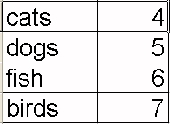
4. Next, insert a picture to represent the data. Your information will be similar to what is shown below:
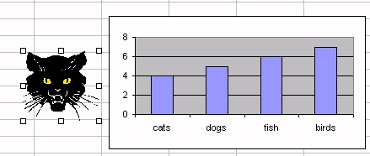
5. With the image selected, select copy from the edit menu. Click on the graph and then select the bar that represents that data. Then select copy from the edit menu. Your image will now appear in your graph.
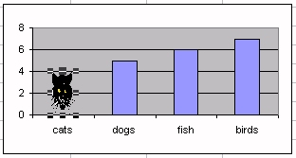
6. Double click the bar with the picture to launch the format data point options. Select the fill effects at the bottom right.
7. Select the picture tab and under format on the left side, choose select and scale to:1. If you would desire each picture to represent two items of data, select 2.
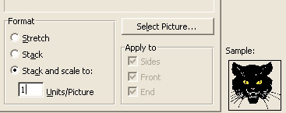
8. Select the second bar so that it is hightlighted. Go to Insert and select clipart. The clipart will automatically appear in the second data set. Repeat this step for the remaining bars.
