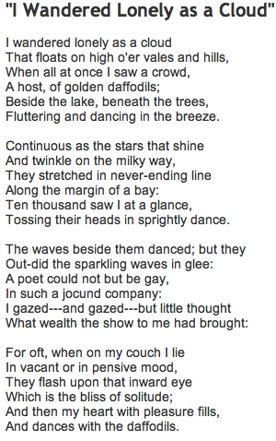
I Wandered Lonely as a Cloud
by William Woodsworth



- Open a new Word document.
- Save as “I Wandered.”
- Read the poem and type the poem as shown
pressing Enter at the end of each line.
- Edit with Spelling / Grammar check.
- Center align the poem.
- Change the font size to 20.
- Change the font style.
- Insert a WordArt title
- Make the author’s name bold and italic.
- Add a Clipart at the bottom.

