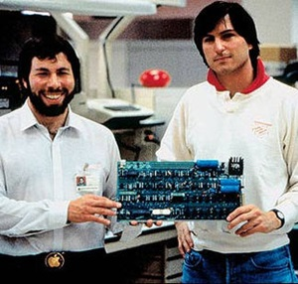

Modern computing has a rich history. Learn about the earliest computing devices developed by humans, the first electronic computers and the development of modern computer components, such as microprocessors and the graphical user interface
.

History of Computers
A computer is an electronic machine that accepts information, stores it, processes it according to the instructions provided by a user and then returns the result. Today, we take computers for granted, and they have become part of our everyday activities. While computers as we know them today are relatively recent, the concepts and ideas behind computers have quite a bit of history - time for a whirlwind tour of how we got to the age of email, YouTube and Facebook.

Early Computing Devices
Attempts by humans to develop a tool to manipulate data go back as far as 2600 BC when the Chinese came up with the abacus. The slide rule was invented in 1621 and remained widely used until the emergence of electronic calculators in the 1970s. Both these examples of early devices were mechanical and on a human scale.
In 1830 the English mathematician Charles Babbage conceived an analytical engine, which could be programmed with punched cards to carry out calculations. It was different from its predecessors because it was able to make decisions based on its own computations, such as sequential control, branching and looping. Almost all computers in use today follow this basic idea laid out by Babbage, which is why he is often referred to as 'the father of computers.' The analytical engine was so complex that Babbage was never able to build a working model of his design. It was finally built more than 100 years later by the London Science Museum.

The First Electronic Computers
Many different types of mechanical devices followed that built on the idea of the analytical engine. The very first electronic computers were developed by Konrad Zuse in Germany in the period 1935 to 1941. The Z3 was the first working, programmable and fully automatic digital computer. The original was destroyed in World War II, but a replica has been built by the Deutsches Museum in Munich. Because his devices implemented many of the concepts we still use in modern-day computers, Zuse is often regarded as the 'inventor of the computer.'
Around the same time, the British built the Colossus computer to break encrypted German codes for the war effort, and the Americans built the Electronic Numerical Integrator Analyzer and Computer, or ENIAC. Built between 1943 and 1945, ENIAC weighed 30 tons and was 100 feet long and eight feet high. Both Colossus and ENIAC relied heavily on vacuum tubes, which can act as an electronic switch that can be turned on or off much faster than mechanical switches, which were used until then. Computer systems using vacuum tubes are considered the first generation of computers.
Vacuum tubes, however, consume massive amounts of energy, turning a computer into an oven. The first semiconductor transistor was invented in 1926, but only in 1947 was it developed into a solid-state, reliable transistor for the use in computers. Similar to a vacuum tube, a transistor controls the flow of electricity, but it was only a few millimeters in size and generated little heat. Computer systems using transistors are considered the second generation of computers.
It took a few years for the transistor technology to mature, but in 1954 the company IBM introduced the 650, the first mass-produced computer. Today's computers still use transistors, although they are much smaller. By 1958 it became possible to combine several components, including transistors, and the circuitry connecting them on a single piece of silicon. This was the first integrated circuit. Computer systems using integrated circuits are considered the third generation of computers. Integrated circuits led to the computer processors we use today.

Personal Computers
Computers become quickly more powerful. By 1970 it became possible to squeeze all the integrated circuits that are part of a single computer on a single chip called a microprocessor. Computer systems using microprocessors are considered the fourth generation of computers.
In the early 1970s computers were still mostly used by larger corporations, government agencies and universities. The first device that could be called a personal computer was introduced in 1975. The Altair 8800 was made by Micro Instrumentation and Telemetry Systems. It included an Intel 8080 processor and 256 bytes of memory. There was no keyboard, and instead programs and data were entered using switches. There was no monitor, and instead results were read by interpreting a pattern of small red lights.
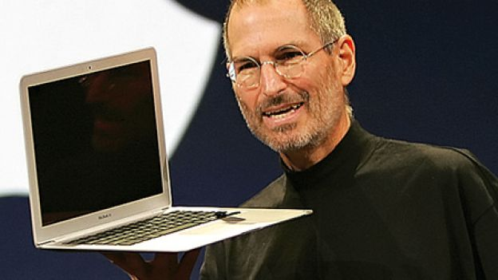
This computer was mostly used by hobbyists and hackers who would take the devices apart and build their own. Two of these hackers, Stephen Jobs and Steve Wozniak, created a personal computer in 1976 that had a keyboard, display and disk storage. They called it the Apple I. Around the same time, two other hackers, Bill Gates and Paul Allen, started to develop software for the Altair 8800 and founded Microsoft.

Date | Event
1936 | The First Computer  The first freely programmable computer came into play.
1947 | The transistor  The transistor was invented by Bell Telephone Company. It wasn't a computer in itself’ but it was a vital computer component.
1953 | IBM  International Business Machines came out with their first computer machine.
1955 | Bank computers  The first bank computers were invented. They used MICR 'or magnetic ink character recognition' to read checks.
1958 | The computer chip  Jack Kilby and Robert Noyce invented the integrated circuit' better known as the computer chip.
1962 | Video games  Spacewar games invented the first computer video games.
1963 | The mouse is invented  Douglas Engelbart invented the computer mouse. He called it the mouse because the cord came out the back like a tail.
1969 | The internet  The first internet was called ARPANET. The original internet wasn't used very widely because not many people had access to it.
1974-1977 | The first personal computers  IBM and Apple were just a couple of the brands that put out the first personal computers.
1975 | Microsoft is born  Bill Gates worked with Paul Allen to develop BASIC for the Altair 8800.
1989 | Microsoft expands  Microsoft made a program that was compatible with IBM computers. This let more people come into contact with the now well-known program.
1991 | The internet as we know it  Tim Berners Less came up with the World Wide Web. He started a computer revolution.
1991 | The laptop comes into play  The first laptop computer ‘the Power Book 100'came out. There were other portable computers before this’ but they were very clunky and expensive.
1996 | World Wide Convention  the first internet convention was held.
1996 | Mini computers  Nokia introduced a phone that had internet capabilities. This started a revolution of devices that were small’ portable computers.

