Poem
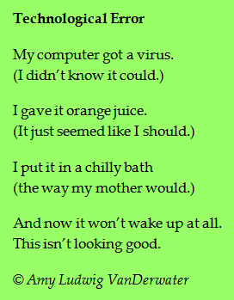
- Open a new Word document.
- On your flash drive, Save As “Poem.”
- Type poem.
- Edit, Spelling and Grammar check.
- Change the font size to 20
and choose a font style.
- Make the word “computer” Bold
and change the font color.
- Make the author’s name Italic.
- Add a Wordart title.
- Add a Clipart.
- Add a Header with your name.
- Add a Footer with the month and year.

