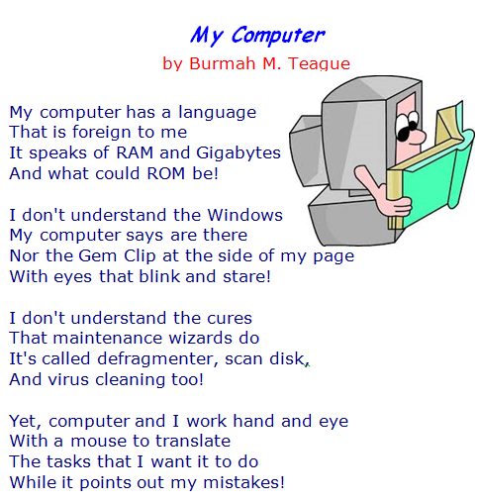

- Read all directions carefully.
- Open a new Word document.
- On your flash drive, Save As “Poem8.”
- Read the poem carefully.
- Type poem.
- Edit, Spelling and Grammar check.
- Change the font size to 20.
- Choose a font style.
- Make the word “computer” Bold throughout the poem and change the font color.
- Make the author’s name Italic.
- Add a Wordart title.
- Add a Clipart.
- Add a page boarder.
- Add a Header with your name.
- Add a Footer with the month and year.

