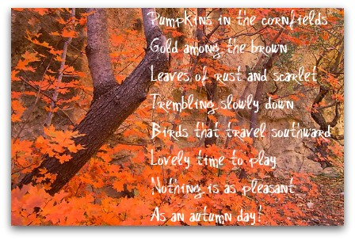

Autumn
Day
Pumpkins in the cornfields
Gold among the brown
Leaves rust and scarlet
Trembling slowly down
Birds that travel southward
Lovely time to play
Nothing is as pleasant
As an autumn day!

- Open a new Word document.
- Save as “Autumn Day.”
- Type your name and
press Enter 3 times.
- Read the poem.
- Type the poem as shown.
- Press Enter at the end of each line.
- Edit with Spelling / Grammar check.
- Center align the poem.
- Change the font size to 20.
- Change the font style.
- Insert a Wordart title.
- Change the color of the words gold, brown, rust and scarlet.
- Make your name italic.
- Insert your Picture at the top.
- Check your work.

