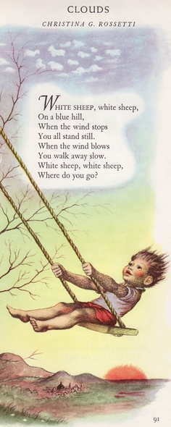
- Open a new Word document.
- Save as “Clouds.”
- Type your name and press Enter 3 times.
- Read the poem.
- Type the poem as shown.
- Press Enter at the end of each line.
- Edit with Spelling / Grammar check.
- Center align the poem.
- Change the font size to 20.
- Change the font style.
- Make the title bold.
- Change the color of the title.
- Make the authors name italic.
- Add a Clipart at the bottom.
- Check your work.

