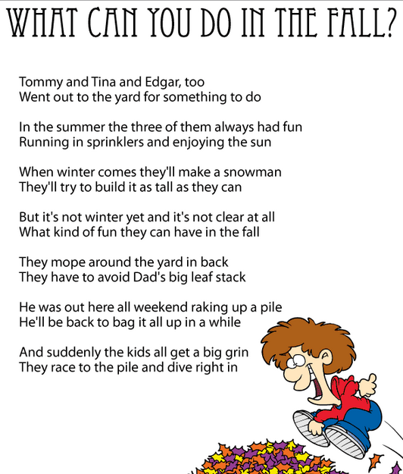
- Open a new Word document.
- Save as “Fall (your name).”
- Type your name and
press Enter 3 times.
- Read the poem.
- Type the poem as shown.
- Press Enter at the end of each line.
- Edit with Spelling / Grammar check.
- Center align the poem.
- Change the font size to 16.
- Change the font style.
- Make the title bold and font
size 20.
- Center title and change the
color of the title and font style.
- Make your name italic.
- Add a Clipart at the bottom.
- Check your work.

