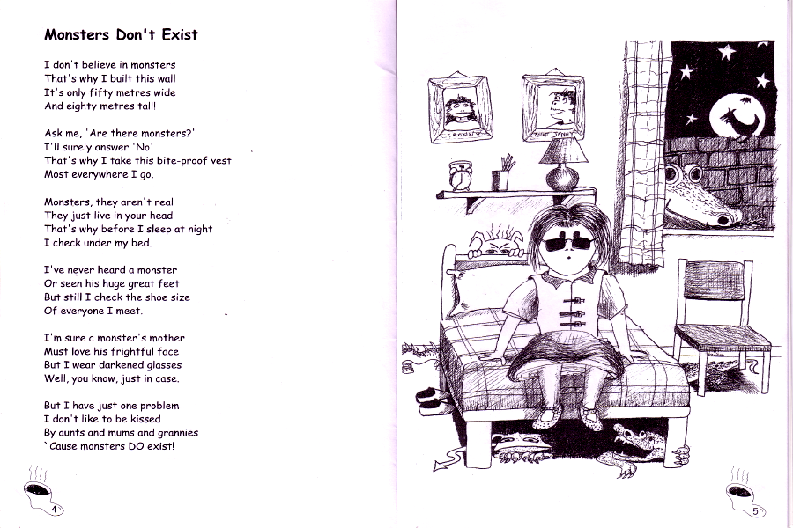
- Open a new Word document.
- Save as “Monsters.”
- Type the poem as shown pressing Enter at the end of each line.
- Edit with Spelling / Grammar check.
- Center align the author’s name, make it bold and italic.
- Change the font size to 14.
- Change the font style.
- Add a WordArt title.
- Change the color of each stanza.
- Add 3 Cliparts and Format.
by Diana Riddell

